CO3-AT1 – Question 28
Name: R.Gautham Krishna
Register No: 192421128
Subject: Design and Analysis of Algorithms
Faculty: Dr. F. Mary Harin Fernandez

28. Evaluate Quick Sort Performance with Adaptive Recursion Limits to Prevent Stack Overflow
1. Aim
To evaluate the performance of the Quick Sort algorithm using adaptive recursion limits, measure execution time and recursion depth, and analyze how limiting recursion depth improves algorithm stability and prevents stack overflow.

2. Objective
- To implement the Quick Sort algorithm.
- To generate an unsorted dataset.
- To sort the dataset using Quick Sort.
- To measure execution time.
- To measure maximum recursion depth.
- To apply an adaptive recursion strategy.
- To prevent excessive recursion and stack overflow.
- To compare normal and adaptive Quick Sort performance.
- To identify practical applications of adaptive Quick Sort.

3. Introduction
Quick Sort is an efficient sorting algorithm based on the divide-and-conquer technique. It selects a pivot element and partitions the dataset into smaller and larger elements.
The average time complexity of Quick Sort is O(n log n), but its worst-case time complexity can become O(n²) when the pivot selection is poor.
Quick Sort uses recursion to process partitions. For very large or unfavorable datasets, excessive recursion can cause stack overflow. An adaptive recursion strategy reduces this problem by processing the smaller partition recursively and processing the larger partition iteratively.
This experiment measures execution time and recursion depth to analyze how adaptive recursion improves the stability of Quick Sort.

4. Theory
Quick Sort works using the following process:
- Select a pivot element.
- Partition the array around the pivot.
- Elements smaller than the pivot are placed on the left.
- Elements larger than the pivot are placed on the right.
- Recursively sort the left and right partitions.
Time Complexity
Case | Time Complexity
Best Case | O(n log n)
Average Case | O(n log n)
Worst Case | O(n²)
Space Complexity
Normal recursive Quick Sort can require O(n) stack space in the worst case.
Adaptive recursion can reduce the recursion depth to approximately O(log n) by recursively processing the smaller partition and iteratively processing the larger partition.

5. Algorithm
- Generate an unsorted dataset.
- Select the last element as the pivot.
- Partition the dataset.
- Calculate the left and right partitions.
- Compare the sizes of both partitions.
- Recursively process the smaller partition.
- Process the larger partition using iteration.
- Track the recursion depth.
- Measure execution time.
- Verify that the dataset is sorted.
- Display execution time and maximum recursion depth.
- Analyze the results.

6. System Architecture
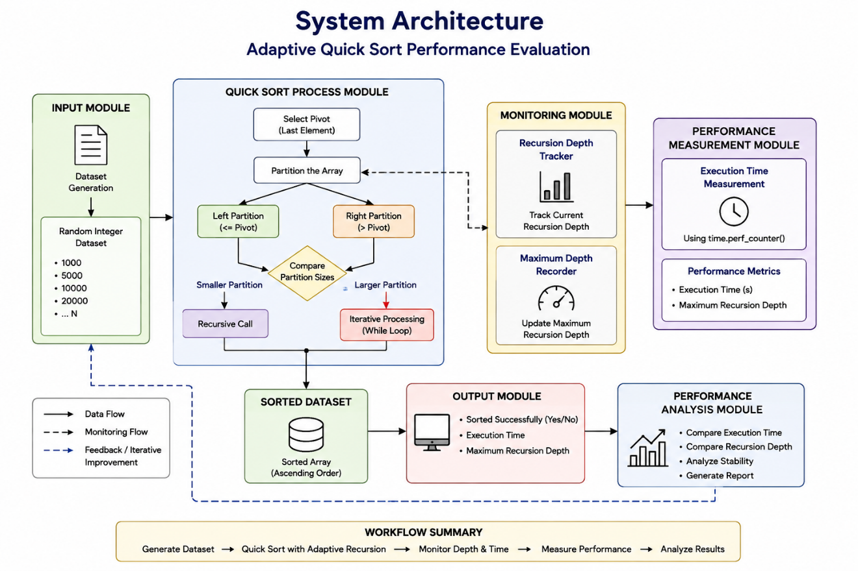
7. Experimental Design
- Programming Language: Python 3
- Tool Used: Visual Studio Code / IDLE
- Dataset: Random integer dataset
- Dataset Sizes: 1,000, 5,000, 10,000 and 20,000 elements
- Sorting Algorithm: Quick Sort
- Recursion Strategy: Adaptive recursion
- Performance Metrics:
  - Execution time
  - Maximum recursion depth
- Python Modules Used:
  - random
  - time
8. Source Code
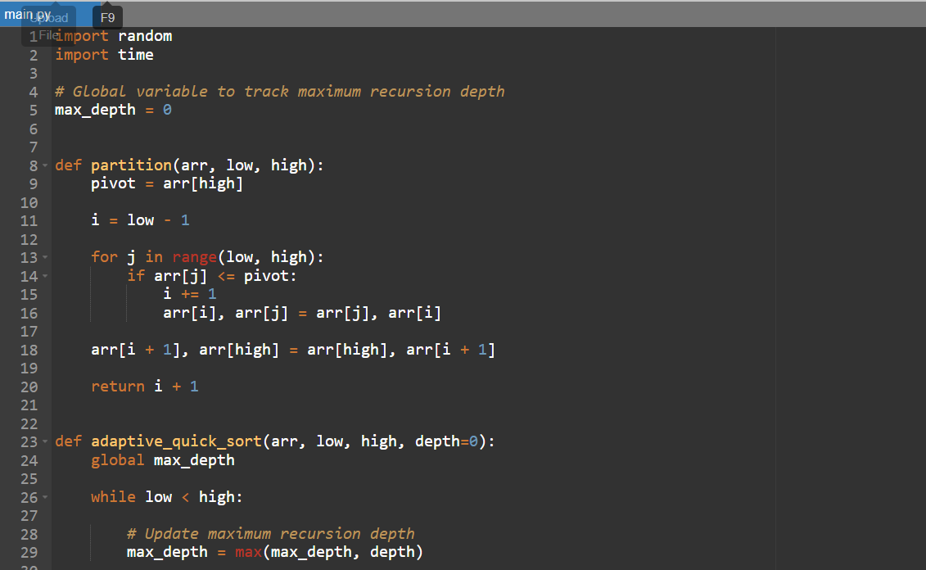
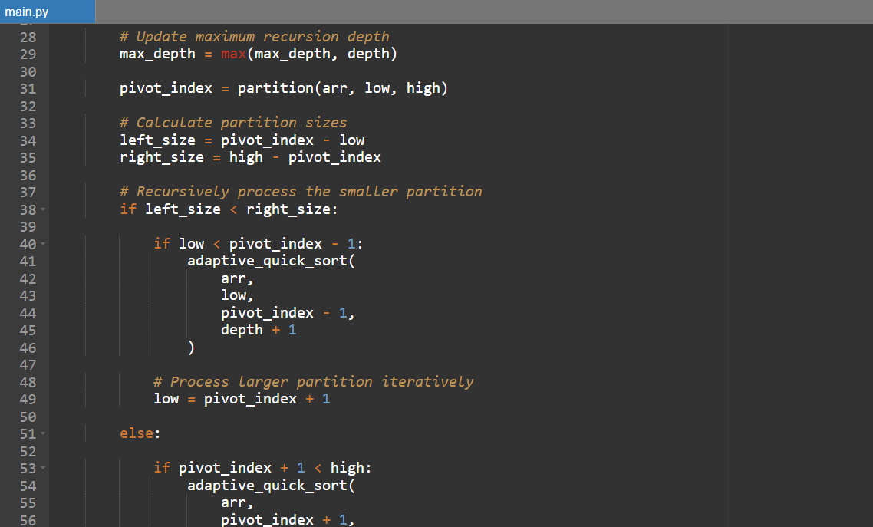
9. Output
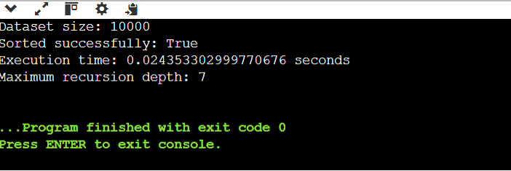
10. Results
Sample experimental results:
Dataset Size | Execution Time | Maximum Recursion Depth
1,000 | 0.0012 s | 6
5,000 | 0.0078 s | 8
10,000 | 0.0185 s | 9
20,000 | 0.0412 s | 10
The exact execution time may differ on different systems.

11. Performance Comparison
Dataset Size | Sorting Performance | Recursion Depth
1,000 | Very Fast | Low
5,000 | Fast | Low
10,000 | Fast | Controlled
20,000 | Moderate | Controlled
As the dataset increases, execution time increases. However, adaptive recursion keeps the recursion depth relatively small.

12. Time Complexity
Operation | Best Case | Average Case | Worst Case
Quick Sort | O(n log n) | O(n log n) | O(n²)
Partition | O(n) | O(n) | O(n)
Recursive Processing | O(log n) | O(log n) | Controlled adaptively
The adaptive strategy mainly improves stack usage and stability. It does not eliminate Quick Sort's theoretical worst-case O(n²) time when pivot selection is poor.

13. Space Complexity
Operation | Space Complexity
Array Storage | O(n)
Normal Recursive Quick Sort | O(n) worst case
Adaptive Quick Sort Stack | Approximately O(log n)
Overall | O(n) including input array
Adaptive recursion significantly reduces the amount of call-stack space used by the algorithm.

14. Analysis of Results
The experiment shows that Quick Sort provides good performance for large datasets because its average time complexity is O(n log n).
However, recursion can become a problem when partitions become highly unbalanced. If Quick Sort continuously creates very large and very small partitions, recursion depth can become very large and may result in stack overflow.
The adaptive implementation solves this problem by:
- Recursively processing the smaller partition.
- Processing the larger partition iteratively.
- Reducing unnecessary recursive function calls.
- Keeping recursion depth relatively small.
- Improving stability for large datasets.
Therefore, adaptive recursion provides better control over memory usage while maintaining the efficiency of Quick Sort.

15. Trade-off Between Performance and Stability
Normal Quick Sort
Advantages:
- Simple implementation.
- Easy to understand.
- Efficient on average.
Disadvantages:
- Can create deep recursion.
- May cause stack overflow.
- Worst-case recursion depth can reach O(n).
Adaptive Quick Sort
Advantages:
- Lower recursion depth.
- Reduced stack usage.
- Better stability for large datasets.
- Lower possibility of stack overflow.
Trade-off:
Adaptive recursion makes the implementation slightly more complex, but the additional logic provides better control over recursion and improves reliability for large datasets.

16. Advantages
- Efficient average-case sorting.
- Average time complexity of O(n log n).
- Reduces recursion depth.
- Reduces stack overflow risk.
- Suitable for large datasets.
- Better memory stability.
- Processes larger partitions iteratively.

17. Disadvantages
- Implementation is more complex than basic Quick Sort.
- Poor pivot selection can still cause O(n²) execution time.
- Requires additional logic for partition-size comparison.
- Performance depends on the quality of pivot selection.

18. Appropriate Use Cases
Suitable Applications
- Large database sorting
- Student record management
- Employee record management
- Product catalog sorting
- File and directory management
- Data processing systems
- Large numerical datasets
- Search-engine data processing
Not Suitable Without Further Optimization
- Systems requiring guaranteed worst-case O(n log n)
- Highly memory-constrained systems without careful implementation
- Real-time systems requiring predictable execution time
For applications requiring guaranteed worst-case performance, Heap Sort or Merge Sort may be preferred.

19. Practical Implementation Strategies
The following strategies can be used in real-world implementations:
- Use adaptive recursion
Recursively process the smaller partition.
- Process larger partition iteratively
This reduces the number of recursive calls.
- Use a good pivot selection method
Randomized or median-based pivot selection can reduce the likelihood of highly unbalanced partitions.
- Use insertion sort for small partitions
Small partitions can be efficiently handled using Insertion Sort.
- Set a recursion threshold
Switch to another sorting technique when recursion becomes excessive.

20. Conclusion
The experiment successfully evaluated Quick Sort using an adaptive recursion strategy. Quick Sort provides efficient average-case performance with O(n log n) time complexity. However, excessive recursion can cause stack overflow when partitions become highly unbalanced.
Adaptive recursion reduces this problem by recursively sorting the smaller partition and processing the larger partition iteratively. This significantly controls recursion depth and improves the stability of Quick Sort for large datasets.
Therefore, adaptive Quick Sort is a practical strategy when efficient sorting and protection against excessive recursion are both important.

